The Asynchronous Start Server Design Document

Security Classification: | Internal
Document Reference: | N/A
Status: | Issued
Version: | 1.0
Team/Department : | Core Development/Networking
Author(s): | Petr Smrz
Owner(s): | Comms-Infras TA

Approver(s): | Networking TA | Distribution: | Symbian and Licensees

Contents
1 Introduction 3
1.1 Purpose and Scope 3
2 Design Overview 3
3 Detailed Design 3
3.1 Synchronous Process Start-up 3
3.1.1 Overview 3
3.1.2 UML Diagram 3
3.1.3 Design Unit Behaviour 4
3.2 Asynchronous Server Start-up 4
3.2.1 Overview 4
3.2.2 UML Diagram 4
3.2.3 Design Unit Behaviour 5
4 Design Considerations 6
5 Further Information 6
5.1 People 6
5.2 References 6
5.3 Open Issues 6
5.4 Glossary 6
5.5 Document History 6
5.6 Document Review Date 6

Introduction

Purpose and Scope
This document provides a description of Asynchronous/Synchronous server/process start-up element. The document is a part of networking base used to create networking components. The target audience is members of the Networking Team developing new components or maintaining the old ones.

Design Overview
The design itself is fairly simple and focuses on two areas:
- Processes synchronisation while avoiding deadlocks
- Asynchronous server start-up as not to block the launching thread
The described functionality is provided by NETSTSRV.DLL element.

Detailed Design

Synchronous Process Start-up

Overview
The synchronous process start-up is fairly simple being done by a single function call. The function blocks the caller thread until the process has been loaded, started and synchronised with. A single class RStartProcess accomplishes Synchronous/Asynchronous process load and start. Please see section 3.2 for how to use the class to asynchronously start a process.

UML Diagram
Table 3-1 gives an overview of the RStartProcess class.
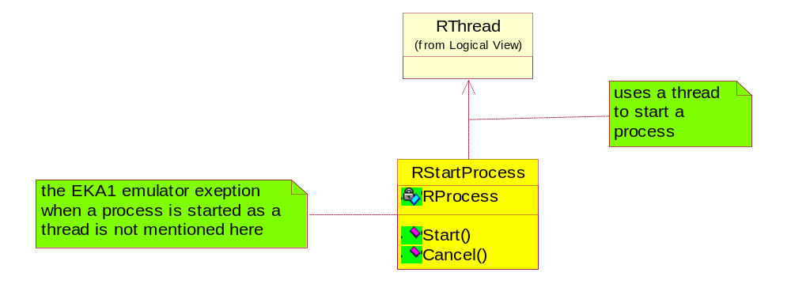

Figure 3-1 RStartProcess class layout.

Object name | Description | Associated (owned/dependant) objects
RStartProcess | Starts process either synchronously or asynchronously. It uses RThread class for the asynchronous start-up. | Owns RProcess to create a process and synchronise with it.
Table 3-1

Design Unit Behaviour
The process start-up can be blocking or non-blocking. This section focuses on the simpler blocking case. The following sequence diagram depicts the actions. Please see 3.2 for non-blocking case.
NETSTSRV :
RStartProcess
to check for
the process
death before
reaching
rendezvous
synchronisation
: RProcess
: Client
Start
Create
Logon
Rendezvous
Resume
Rendezvous
return KErrNone

Figure 3-2 Blocking process start-up

Asynchronous Server Start-up

Overview
The asynchronous server start-up creates a thread to load, start and synchronise with a process so that the caller thread is not blocked. The above mentioned RStartProcess can be used for non-blocking process start-up as obvious from the Figure 3-1. However now we need someone to wait for us to finish. The following picture shows the RStartProcess class relationship to the active object waiting for a result.

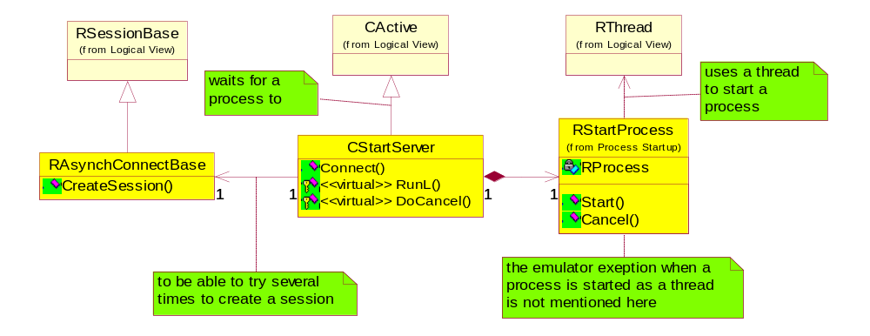
UML Diagram

Figure 3-3 Non-blocking start server class layout
Object name | Description | Associated (owned/dependant) objects
CStartServer | Waits for the server start and attempts to create a session. It keeps trying until it succeeds or runs out of predefined attempts. Then it completes a user request. | Owns RAsynchConnectBase to access RSessionBase::CreateSession protected member.
RStartProcess | Creates RProcess either in separate or the caller’s thread and synchronises with the new process via rendezvous. | RProcess to start and synchronise with a process. Uses RThread to start the process within if asked to do so.
Table 3-2 Server start-up Class description

Design Unit Behaviour
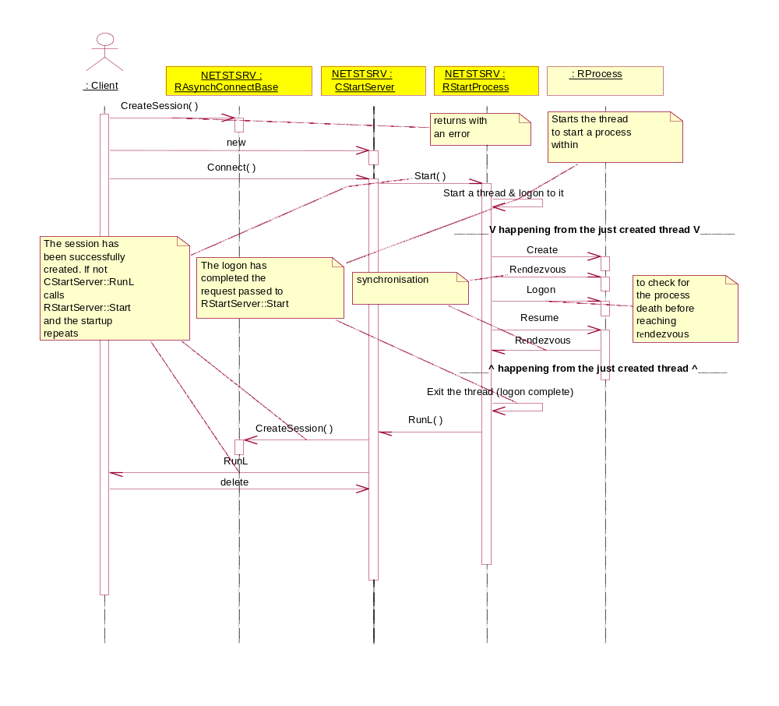
As the figure 3-4 shows, a class CStartServer is used to asynchronously create a server process while connecting to it for the first time. The class CStartServer waits for the server to start and attempts to create a session. It keeps trying until its succeeds or runs out of predefined attempts. In any case it completes the user request. The CStartServer uses RStartProcess to do the actual RProcess creation and synchronisation work. RStartProcess can do its job in a separate or the caller’s thread.
Figure 3-4 Non-blocking server start-up

Design Considerations

Further Information

People
Role | Person / People
Contributor(s) | Kevin Benton
Reviewer(s)

References
No. | Document Reference | Version | Description
[R1] | Start Server Design | 0.1 | UML of diagram
[2] | CSDAEMON code |  | Element usage example

Open Issues
The following issues need to be resolved before this document is completed;
- What to do on cancel non-blocking server start-up

Glossary
The following technical terms and abbreviations are used within this document.
Term | Definition

Document History
Date | Version | Status | Description
06-02-2004 | 1.0 | Issued | Updated with minor additions
11-12-2003 | 0.1 | Draft | Created

Document Review Date

